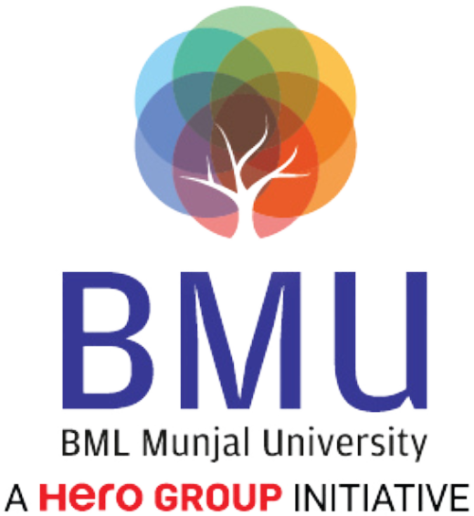

**SCHOOL OF ENGINEERING & TECHNOLOGY**

**COURSE FILE**

**Program**: Computer Science Engineering

**Course Code:** CSE4006

**Course Title:** Blockchain  
Module Semester: VI

**Session:** 2021-2022

**Index**

|  |  |
| --- | --- |
| **S. No.** | **Topics** |
| **1.** | Course Details: Course-Code; Course Title; Semester/Term/Module; Year |
| **2.** | Vision, Mission of the University |
| **3.** | Graduate Attributes of the BMU Students |
| **4.** | Vision, Mission of the School |
| **5.** | PEOs and POs & PSOs of the Program |
| **6.** | Course Description and its objectives |
| **7.** | Course Outcomes and CO-PO Mapping |
| **8.** | Detailed Session wise Plan & Course Syllabus: (including Course Content with Module-wise teaching hours allocated; Readings, Activities, Teaching Strategy, and Module mapped to COs, Textbook(s), Reference Books, Other learning resources) |
| **9.** | Weekly Timetable |
| **10.** | Registered Students List |
| **11.** | Details of Internal Assessments; weightages, due dates, mapping to CO |
| **12.** | Mid-Semester Question papers with sample solutions |
| **13.** | Sample Evaluated Internal Submissions and Identification of weak students. |
| **14.** | Reflections from the Mid-term semester feedback received, and interventions made to enhance student learning and continuous improvement in teaching and learning strategies. |

|  |  |
| --- | --- |
| **15.** | Interventions made for slow performers and advanced learners, highlighting initiatives taken for student improvements (retest, resubmissions etc.) |
| **16.** | End Semester Question papers with sample solutions |
| **17.** | Details of Marks in all components up to the End Semester including the grades |
| **18.** | Identification of advanced learners and low performers conducted at the end of the semester |
| **19.** | Attendance Report |
| **20.** | CO attainment analysis with the reflection on feedback on course outcomes |
| **21.** | Feedback (class committee or otherwise) and corrective actions (if any) |
| **22.** | Faculty Course Review (if any, like Use of Innovative Pedagogies; Technology; Experiential Learning; Integration with the Vision and Mission of the University; Feedback; Course Outcome attainment for the next run of the course) |
| **23.** | Any other additional information |

# Course Details

* + **Course Code:** CSE4006
  + **Course Title:** Blockchain

## **Module/Semester:** VI

* + **Session:** 2021-2022

# Vision, Mission of the University

## Vision

BML Munjal University seeks to nurture ethical leaders who are skilled, knowledgeable and have the life skills required for leading their organizations to success. The university shall seek the advancement and dissemination of practically oriented knowledge benchmarked with the best global standards.

## Mission

BML Munjal University aims to be a leading university for the quality and impact of its teaching, research and linkages with major stakeholders. The focus of the university is to find creative solutions to problems through application of knowledge. The university aims to create a talented community of students and faculty who excel in teaching, learning and research, in a creative and stimulating environment. The university will collaborate with other institutions for development of science, technology and arts in the global context.

# Graduate Attributes

* + Acquire and apply practical understanding of discipline knowledge.
  + Demonstrate a sense of ethics and display excellence in both personal and professional life.
  + Exhibit problem solving, critical thinking skills and investigative capability to address real world problems.
  + Manifest leadership qualities and work effectively in teams across globally diverse environments.
  + Be a lifelong learner with an entrepreneurial mindset to innovate in the constantly changing global scenario.
  + Possess a strong sense of inquiry and design innovative solutions for positive societal impact.
  + Be effective communicators and possess an empathetic outlook.

# Vision, Mission of the School

## Vision of School:

To be amongst the leading engineering schools of the country recognized globally for excellence in teaching and research with focus on experiential learning, innovation and entrepreneurship.

## Mission of School:

* Providing high-quality learning experience to our students, preparing them to be global leaders, and contributing to the development of society through research, innovation, and entrepreneurship.
* Creating an inclusive and diverse learning environment that fosters creativity, critical thinking, and ethical values.
* Collaborating with industry, government, and other institutions to address complex societal challenges and promote sustainable development.

# 5. PEOs and POs & PSOs of the Program

# Program Educational Objectives (PEO):

# PEO 1: Identify real-life problems and develop creative and innovative hardware/software-based solutions.

# PEO 2: Achieve professional development through self-learning to adapt to the technological changes in the ever changing field of computing.

# PEO 3: Engage in life-long learning of computer engineering technologies, critical thinking and continuous ingenuity and apply them in real-life applications.

# PEO 4: Accomplish leadership roles by imbibing ethics and professionalism with emphasis on sustainable development of the society.

# Program Outcomes (PO):

# PO1: Apply the foundational concepts of mathematics, science and computer engineering to find novel solutions for complex real-life engineering problems.

# PO2: Identify, formulate, review literature and analyze complex computer engineering problems reaching substantiated conclusions and derive a coherent logic that can be implemented by computers.

# PO3: Design analytical and computational models for solving complex engineering problems giving due consideration to issues related to public health and safety, cultural and societal constraints, and environmental concerns.

# PO4: Use research-based knowledge, methods, tools and techniques for data collection, designing digital computing systems, analyzing and interpreting the results to provide substantiated conclusions.

# PO5: Use appropriate tools to model complex computer engineering problems through identification of the limitations and creating solutions to predict the real-world phenomena.

# PO6: Use appropriate contextual knowledge of computer engineering to review and assess societal, health, legal, cultural, safety and contemporary issues and rationalize the ensuing responsibilities towards the society.

# PO7: Adopt computer engineering practices in congruence with societal need, understand the working practices and its impact on natural resources for sustainable development.

# PO8: Use ethical principles to pursue excellence in developing computer engineering systems and behave appropriately to develop a reliable and trustworthy relationship with others.

# PO9: Function effectively as a reliable and responsible individual, and as a member or leader in diverse computer engineering teams, and in multidisciplinary settings, thereby placing team goals ahead of individual interests.

# PO10: Communicate effectively by capturing the desirable computer system requirements for preparation of specification documents, write clear and concise report such as laboratory files, research papers, thesis, and presentation materials.

# PO11: Demonstrate knowledge of computer engineering and management principles for the completion of individual or group projects in multidisciplinary environments.

# PO12: Recognize the evolving technological changes and engage as an independent and life-long learner in both computing and non-computing fields.

# Program Specific Outcomes (PSO):

# PSO1: Identify applicable tools and techniques related to data science practice such as data collection, cleaning, analysis, modelling, evaluation and result interpretation and apply them for deriving hidden and meaningful patterns for appropriate actionable insights.

# PSO2: Develop intelligent systems for various real-life domains like healthcare, transportation, finance etc. using Artificial Intelligence methodologies.

# PSO3: Understand the foundational concepts and techniques to protect computing systems against constantly evolving cybersecurity threats and analyze security breaches and violations of cyber systems and networks to provide appropriate solutions.

# PSO4: Design effective security systems to mitigate risks, threats and vulnerabilities for protecting the organizations against cyber threats.

# 7. Course Outcomes and CO-PO Mapping

**Course Outcomes:**

CO1:

**CO/PO Mapping:**

|  |  |  |  |  |  |  |  |  |  |  |  |  |  |  |  |  |  |
| --- | --- | --- | --- | --- | --- | --- | --- | --- | --- | --- | --- | --- | --- | --- | --- | --- | --- |
| Course Outcomes (CO) | CO/PO | PO1 | PO2 | PO3 | PO4 | PO5 | PO6 | PO7 | PO8 | PO9 | PO10 | PO11 | PO12 | PSO1 | PSO2 | PSO3 | PSO4 |
| CO1 | 0 | 0 | 0 | 0 | 0 | 0 | 0 | 0 | 0 | 0 | 0 | 0 | 0 | 0 | 0 | 0 | 0 |

# 8. Detailed Session wise Plan & Course Syllabus

|  |  |  |  |
| --- | --- | --- | --- |
| **Sr. No.** | **Content** | **CO** | **Sessions** |
| 1 |  |  | 1 |

# Learning Resources

## **Text Books:**

## **Reference Links:**

# 9. Weekly Timetable

|  |  |  |  |  |  |
| --- | --- | --- | --- | --- | --- |
| **Time** | **Monday** | **Tuesday** | **Wednesday** | **Thursday** | **Friday** |
| 9:15-10:10 |  |  |  |  |  |
| 10:15-11:10 |  |  |  |  |  |
| 11:15-12:10 |  |  |  |  |  |
| 12:15-13:10 |  |  |  |  |  |
| 13:15-14:10 |  |  |  |  |  |
| 14:15-15:10 |  |  |  |  |  |
| 15:15-16:10 |  |  |  |  |  |
| 16:15-17:10 |  |  |  |  |  |
| 17:15-18:10 |  |  |  |  |  |

# 11. Internal Assessment Data

|  |  |  |  |  |
| --- | --- | --- | --- | --- |
| **Component** | **Duration** | **Weightage** | **Evaluationweek** | **Remarks** |
|  |  |  |  |  |

# 12. Assignment PDF

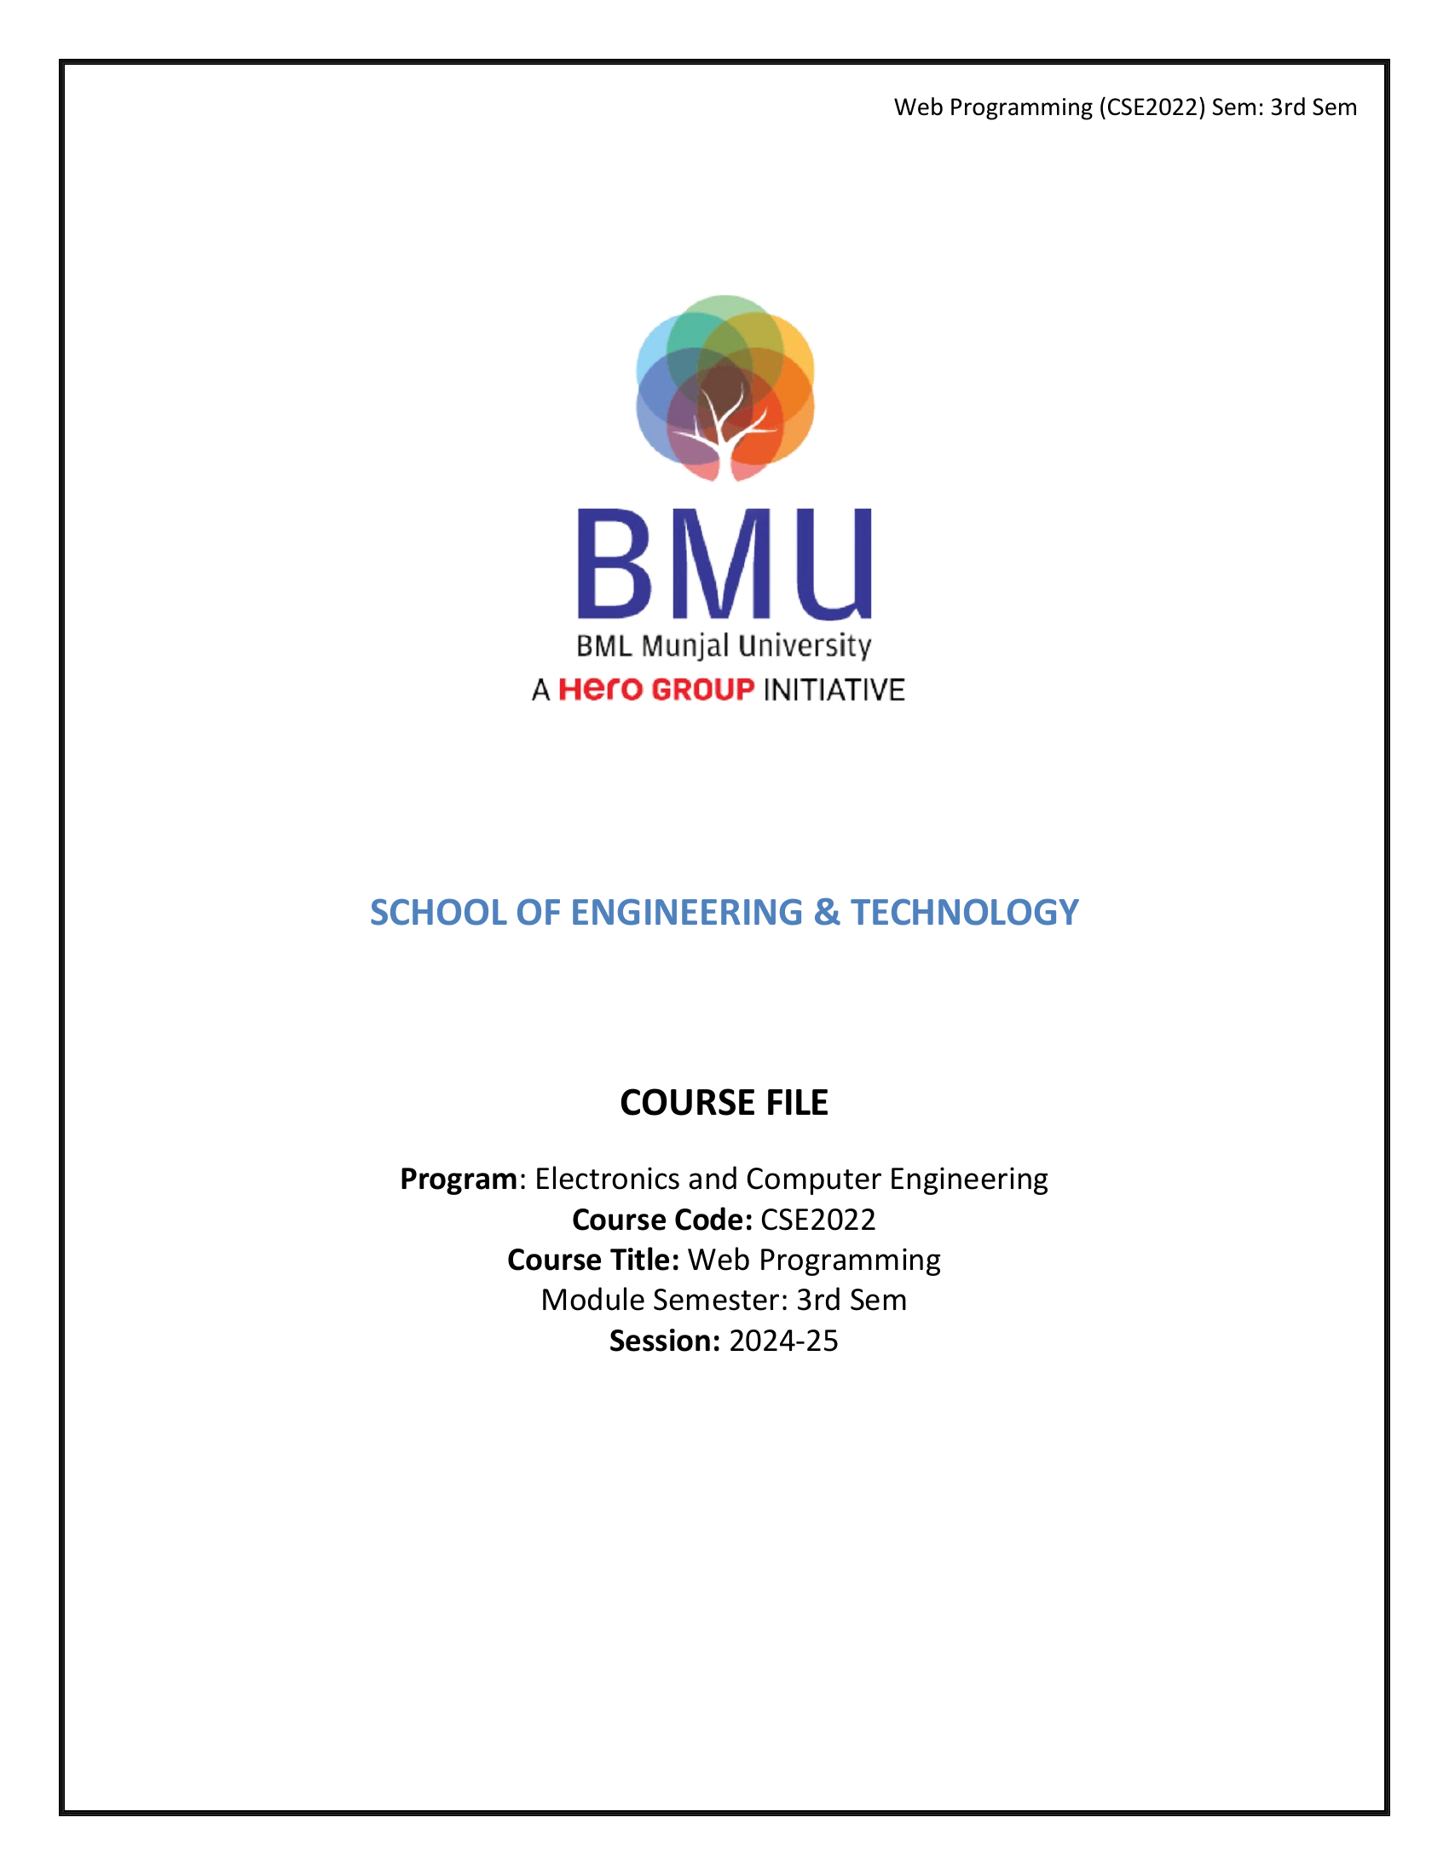

This image is the first page of the embedded PDF.

# 13. Sample Evaluated Internal Submissions and Identification of weak students.

## Learner Categories Summary for Partial Semester

|  |  |
| --- | --- |
| **Learner Category** | **Number of Students** |
| Advanced Learners | 0 |
| Medium Learners | 0 |
| Low Performers | 0 |

## Student Learning Classification for Partial Semester

|  |  |
| --- | --- |
| **Student Name** | **Category** |

# 15. Actions taken for low performers

•

# 20. CO attainment analysis with the reflection on feedback on course outcomes

## CO Attainment Summary

|  |  |
| --- | --- |
| **Course Outcomes** | **CO1** |
| Weights | 0.00% |
| No. of students who scored at the highest attainment level (3) | 0 |
| Percentage of students who scored at the highest attainment level (3) | 0.00% |
| Attainment Level | 2 |
| **Overall Course Attainment** | **2.0000** |

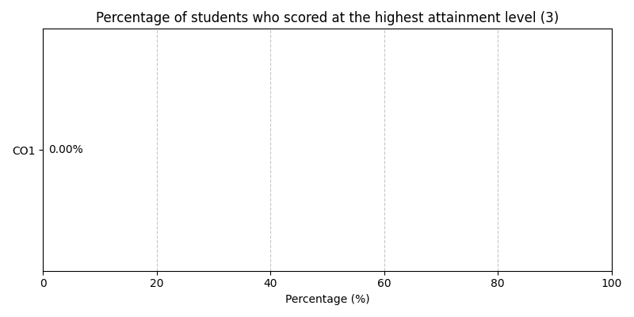

## Program Attainment

|  |  |  |  |  |  |  |  |  |  |  |  |  |  |  |  |  |  |
| --- | --- | --- | --- | --- | --- | --- | --- | --- | --- | --- | --- | --- | --- | --- | --- | --- | --- |
| **Program Outcomes** | **CO/PO** | **PO1** | **PO2** | **PO3** | **PO4** | **PO5** | **PO6** | **PO7** | **PO8** | **PO9** | **PO10** | **PO11** | **PO12** | **PSO1** | **PSO2** | **PSO3** | **PSO4** |
| Program Attainment | 0.00 | 0.00 | 0.00 | 0.00 | 0.00 | 0.00 | 0.00 | 0.00 | 0.00 | 0.00 | 0.00 | 0.00 | 0.00 | 0.00 | 0.00 | 0.00 | 0.00 |

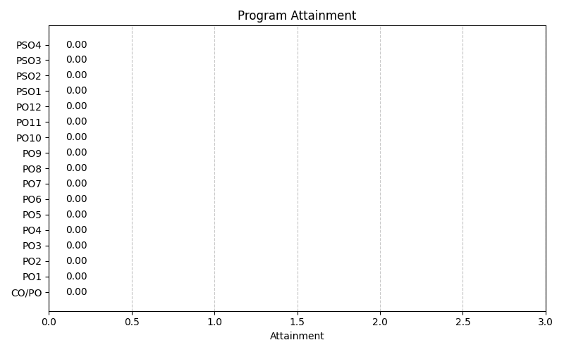

# 21. Feedback (class committee or otherwise) and corrective actions (if any)

**Quantitative Feedback:**

Average Rating: 0.00/5